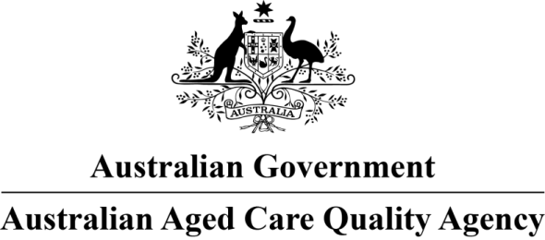

Australian Vietnamese Aged Care Services

Approved Provider: Australian Vietnamese Aged Care Services

This is a new home and is accredited for one year until 02 April 2019. We made the decision on 27 March 2018.

We are satisfied the home will undertake continuous improvement, measured against the Accreditation Standards.

We will monitor the performance of the home including through unannounced visits.

# Home and approved provider details

|  |  |
| --- | --- |
| Home name: | Australian Vietnamese Aged Care Services |
| RACS ID: | 9212 |
| Approved provider: | Australian Vietnamese Aged Care Services |
| Number of beds: | 68 |
| Number of high care residents: | Nil |
| Special needs group catered for: | Dementia specific |
| Home address: | 783 – 785 The Horsley Dr Smithfield NSW 2164 |
| Phone: | 02 9746 7375 |
| Facsimile: | 02 9746 3580 |
| Email address: | Drdavidtracey.tang@avacsnsw.com.au |