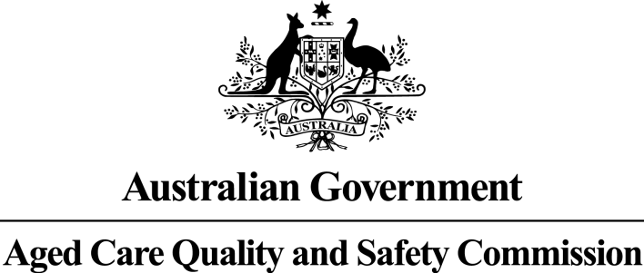

Consumers’ Experience of the Quality of Care and Services: Aged Care Services

Barossa Village Incorporated

RACS ID: 6023

Audit dates: 11 November 2019 to 13 November 2019

An audit team from the Aged Care Quality and Safety Commission (Commission) visited the aged care service for re-accreditation purposes and spoke to at least 10 per cent of the people who live there. Those we interviewed for this report were randomly selected. The results are presented in this report which will help you understand the experience of consumers living at the service. It should be read alongside the audit report on the service available at the Commission’s Report Search page at <https://www.agedcarequality.gov.au/reports>. For more general information on aged care, visit the [My Aged Care website](http://www.myagedcare.gov.au).

Number of consumers interviewed: 11

Number of representatives interviewed: 3

# What is your experience at the service?

1. Do you like the food here?

93 per cent of respondents say they like the food most of the time or always.

2. Do you feel safe here?

100 per cent of respondents say they feel safe most of the time or always.

3. Is this place well run?

100 per cent of respondents say that this place is well run most of the time or always.

4. Do you get the care you need?

100 per cent of respondents say they get the care they need most of the time or always.

5. Do staff know what they are doing?

93 per cent of respondents say that the staff know what they are doing most of the time or always.

6. Are you encouraged to do as much as possible for yourself?

86 per cent of respondents say they are encouraged to do as much as possible for themselves most of the time or always.

7. Do staff explain things to you?

93 per cent of respondents say staff explain things to them most of the time or always.

8. Do staff treat you with respect?

100 per cent of respondents say staff treat them with respect most of the time or always.

9. Do staff follow up when you raise things with them?

100 per cent of respondents say staff follow up when they raise things with them most of the time or always.

10. Are staff kind and caring?

100 per cent of respondents say staff are kind and caring most of the time or always.

11. Do you have a say in your daily activities?

100 per cent of respondents say they have a say in their daily activities most of the time or always.

12. Do you feel at home here?

93 per cent of respondents say they feel at home here most of the time or always.