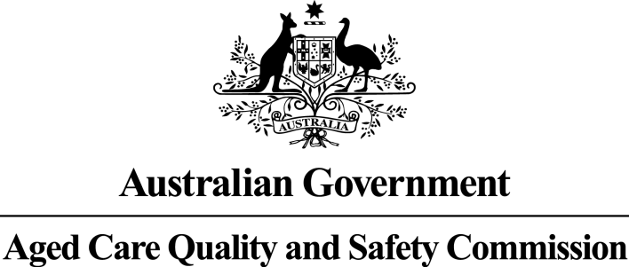

Consumers’ Experience of the Quality of Care and Services: Aged Care Services

Karingal Seymour

RACS ID: 3050

Audit dates: 10 July 2019 to 12 July 2019

An audit team from the Aged Care Quality and Safety Commission (Commission) visited the aged care service for re-accreditation purposes and spoke to at least 10 per cent of the people who live there. Those we interviewed for this report were randomly selected. The results are presented in this report which will help you understand the experience of consumers living at the service. It should be read alongside the audit report on the service available at the Commission’s Report Search page at <https://www.agedcarequality.gov.au/reports>. For more general information on aged care, visit the [My Aged Care website](http://www.myagedcare.gov.au).

Number of consumers interviewed: 19

Number of representatives interviewed: 0

# What is your experience at the service?

1. Do staff treat you with respect?

100 per cent of respondents say staff treat them with respect most or all of the time.

2. Do you like the food here?

78 per cent of respondents say they like the food most or all of the time.

3. Do you feel safe here?

100 per cent of respondents say they feel safe most or all of the time.

4. Is this place well run?

100 per cent of respondents agree or strongly agree that this place is well run.

5. Do you get the care you need?

100 per cent of respondents say they get the care they need most or all of the time.

6. Do staff know what they are doing?

100 per cent of respondents agree or strongly agree that the staff know what they are doing.

7. Are you encouraged to do as much as possible for yourself?

100 per cent of respondents say they are encouraged to do as much as possible for themselves most or all of the time.

8. Do staff explain things to you?

94 per cent of respondents say staff explain things to them most or all of the time.

9. Do staff follow up when you raise things with them?

94 per cent of respondents say staff follow up when they raise things with them most or all of the time.

10. Are staff kind and caring?

100 per cent of respondents say staff are kind and caring most or all of the time.

11. Do you have a say in your daily activities?

94 per cent of respondents say they have a say in their daily activities most or all of the time.

12. Do you feel at home here?

94 per cent of respondents say they feel at home here most or all of the time.