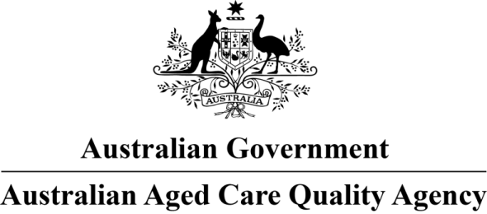
The Richardson West Perth
Approved Provider: Oryx Communities AP Pty Ltd
This is a new home and is accredited for one year until 11 July 2019. We made the decision on 11 July 2018.
We are satisfied the home will undertake continuous improvement, measured against the Accreditation Standards.
We will monitor the performance of the home including through unannounced visits.

Home and approved provider details
Home name: | The Richardson West Perth
RACS ID: | 9730
Approved provider: | Oryx Communities AP Pty Ltd
Number of beds: | 78
Number of high care residents: | Nil
Special needs group catered for: | Nil
Home address: | 32 Richardson Street WEST PERTH WA 6005
Phone: | 08 9381 2800
Facsimile:
Email address: | contact@oryxcommunities.com.au

