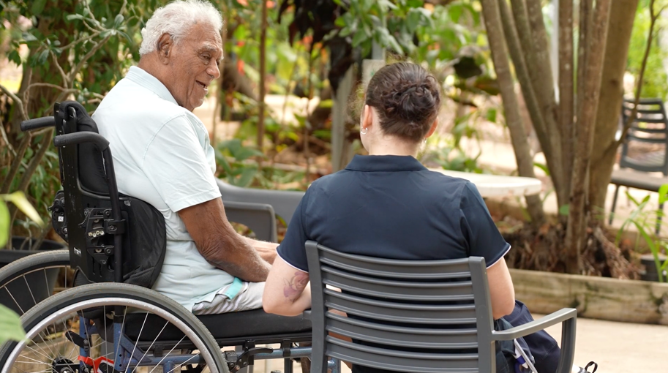

INSTRUCTION: You can replace this photo with your own image. Right click on the image, click ‘Change Picture' and select the one you want. Delete this text box when you’re finished.

INSTRUCTION: Double click in the grey box to add details for your local contact, like a person’s or organisation’s name, phone number, and email address. Delete this text box when you’re finished.

[Add local contact details here]