  
**Contents**

**Aged Care Approved Provider Applicant Guide**

July 2024

Introduction 6

About the Commission 6

Purpose of this guide 7

Types of care 7

Why become an approved provider 9

When you do not need to be approved 9

Types of applications 10

**Overview of the application process 10****2**

Part A: Before you apply 13

Before you apply 14

Read all relevant information 14

Ensure that you meet the requirements 16

Complete the application form 19

Submit your application 19

Part B: Assessment process 20

Assessment process 21

Validity check 21

Initial assessment 22

Formal assessment 23

Decision and finalisation 24

After your application is decided 25

If you are approved 25

If you are not approved 28

Fees and fee waiver 30

Application fees 30

Request for Information fees 31

Application fee waiver 32

Part C: Completing the application form 34

General guidance 35

Application checklist 37

Key personnel declaration 37

Section 1 – About the applicant 38

Corporate structure 40

Business plan 40

Use of another organisation (subcontract arrangements) 40

Section 2 – Your key personnel 42

Section 3 – Your suitability to be an approved provider 45

Experience, conduct and compliance 45

Governance systems 46

Financial management 46

Responsibilities as a provider – quality of care, user rights and accountability 47

Section 4 – Your ability to meet care type specific matters 48

Completing the government organisation form 49

Important requirements for all applicants

Your application will not be successful unless you can demonstrate that you meet all of the following requirements.

Is the applicant organisation an incorporated body?

Your organisation must be incorporated under Commonwealth, state or territory law. This means that you must be an incorporated company or an incorporated association.

Does the Board or Governing body of your organisation have relevant skills and direct experience in leading an aged care or other care-based service?

Your Board or Governing body is legally accountable for the delivery of care services in line with the Aged Care Quality Standards.

You must demonstrate that members of your Board or Governing body have direct relevant experience in leading an aged care service or similar service.

Every member of your Board or Governing body is key personnel and meet the mandatory key personnel requirements – there are no exceptions.

*Note: if your application is approved after 1 December 2022 you will be required to meet the new responsibilities in relation to governing bodies and advisory bodies. However, Government organisations are no required to meet these responsibilities. More information about these changes is available on the Commissions website:* [*Provider responsibilities relating to governance - Guidance for approved providers*](https://www.agedcarequality.gov.au/resources/provider-responsibilities-relating-governance-guidance-approved-providers-draft-14-november-2022)

Does the Executive team have relevant experience and qualifications for delivering aged care services?

You must be able to describe the specific responsibilities of each member of the Executive team and show how their skills and experience match those responsibilities.

If you are applying for residential care and or in-home care, your Executive team must include a person who will have responsibility for the delivery of clinical care. That person must have appropriate clinical experience and, as a minimum, must be a currently registered nurse.

Every member of your Executive team must be included as key personnel and meet the mandatory key personnel requirements – there are no exceptions.

Can you show how your care services will meet the requirements of the Aged Care Act and Aged Care Quality Standards?

You must be able to describe your organisation’s governance framework. This means the business systems, policies, procedures, monitoring and improvement mechanisms that you will use to manage the delivery of care services.

You must be able to describe how your governance arrangements will ensure that the care services you deliver meet the requirements of aged care regulation and the Aged Care Quality Standards. For example, this would include the arrangements that you have in place to ensure that you deliver consumer-centred care.

Can you show how you will fund the establishment and operation of care services and demonstrate financial viability?

You must show how you will fund the establishment and operation of your care service, including evidence of commitment for any relevant capital investments or loans.

You must provide evidence that organisations or individuals who are funding loans or capital investments have the necessary funds.

If applicable, you must be able to show the method you use to set prices.

If you are delivering in-home or community care services, you must show the controls you have in place to monitor and manage your cash flow, noting that government subsidy payments are made in arrears.

If you are establishing or intending to take ownership of a residential aged care service that will or has previously used the refundable accommodation deposit as a funding stream, you must show how you will manage liquidity, governance, record keeping and disclosure obligations in accordance with the prudential standards.

You must demonstrate that you maintain a financial management system that captures the data that you are required to regularly report to the Department of Health and Aged Care and to consumers.

Can you show how any subcontracting arrangements will ensure that the care services delivered meet the Aged Care Quality Standards?

You are legally accountable for the delivery of care services through subcontractors. Your contractual arrangements must ensure that the care services delivered meet aged care regulation, including the Aged Care Quality Standards.

You must provide a copy of the service agreement that you will use with subcontractors to demonstrate how you will ensure that all care services will be delivered in accordance with the standards.

If you cannot provide a copy of the service agreement, you must provide details of the terms and conditions that will be included.

Introduction

About the Commission

The Aged Care Quality and Safety Commission (the Commission) is the national regulator of Australian Government–funded aged care services.

Our main purpose is to protect and enhance the safety, health, wellbeing and quality of life of people receiving aged care by holding providers to account for the services and care they deliver.

Our functions include approving providers’ entry to the aged care system; accrediting, assessing and monitoring aged care services; resolving complaints about aged care services; and taking action to ensure compliance, when necessary.

These processes are carried out in accordance with the Aged Care Quality and Safety Commission Act 2018([Commission Act](https://www.legislation.gov.au/Details/C2021C00436)) and the Aged Care Quality and Safety Commission Rules 2018 ([Commission Rules](https://www.legislation.gov.au/Details/F2021C00893)).

We assess and monitor approved providers against the [Aged Care Quality Standards](https://www.agedcarequality.gov.au/providers/standards). All approved providers must understand their full regulatory responsibilities, including under the Aged Care Act 199*7* ([Aged Care Act](https://www.legislation.gov.au/Series/C2004A05206)) and the Aged Care Quality Standards, and implement policies, processes and systems to ensure that they comply.

Privacy policy

Our [Privacy Policy](https://www.agedcarequality.gov.au/about-us/legislation-and-policies/privacy-policy) outlines how we manage personal information and safeguard privacy under the Privacy Act 1988and the Australian Privacy Principles.

Read our Privacy Policy before you complete and submit your application.

Contact details

Questions relating to an approved provider application should be emailed to [approvedproviderapplications@agedcarequality.gov.au](mailto:approvedproviderapplications@agedcarequality.gov.au)

Purpose of this guide

This guide helps you complete an application form to be an approved provider of aged care. It includes information about the application process, including the fees you must pay to apply, and explains the conditions and criteria that you must meet before you apply.

You must:

* understand the legal requirements of being an approved provider
* be able to demonstrate your ability to comply with these requirements.

The Commission website has more information about [becoming an approved aged care provider](https://www.agedcarequality.gov.au/providers/becoming-approved-aged-care-provider).

More details are also in each of the application forms:

* [new applicants](https://www.agedcarequality.gov.au/media/87218)
* [existing approved providers](https://www.agedcarequality.gov.au/media/87219)
* [government organisations](https://www.agedcarequality.gov.au/media/87220)

Most of this guide is aimed at new applicants, or existing approved providers who want to provide another care type.

Types of care

Regardless of the care type(s) you are seeking approval to provide, your application will be assessed in accordance with suitability matters set out under Part 7A of the Commission Act and the responsibilities of an approved provider under the Aged Care Act.

Residential care

[Residential aged care](https://www.health.gov.au/initiatives-and-programs/residential-aged-care) is for eligible older Australians who are no longer able to live in their own home.

It includes accommodation and personal care that is delivered 24 hours a day, as well as access to nursing and general healthcare services.

Even after approval, you cannot receive residential care subsidies for the provision of residential aged care as an approved provider unless you are also [accredited by the Commission](https://www.agedcarequality.gov.au/providers/assessment-processes/accreditation-and-re-accreditation).

Home care

The [Home Care Packages (HCP) program](https://www.health.gov.au/initiatives-and-programs/home-care-packages-program) supports older Australians with complex care needs to live independently in their own homes. It uses a consumer-directed care approach to ensure that the support suits their needs and goals.

The HCP program delivers coordinated packages of care and services to meet the assessed care needs of older people within the limits of their individual home care budgets and the scope of the program.

How care and services are identified and delivered should carefully reflect and respect the individual, and their care needs, personal situation and preferences.

Also see the [HCP Program Manual](https://www.myagedcare.gov.au/publications/home-care-packages-manual) (for consumers) or [HCP Operational Manual: A Guide for Home Care Providers](https://www.health.gov.au/resources/publications/home-care-packages-program-operational-manual-a-guide-for-home-care-providers) for detailed information about this program.

Flexible care

There are different types of flexible care, depending on the person’s needs. They all help with day-to-day tasks, and to restore or maintain independence.

Flexible care is for care recipients who need a different approach from residential and home care.

An approval to provide flexible care is an approval to provide care under the [Short-term Restorative Care (STRC) Programme](https://www.health.gov.au/initiatives-and-programs/short-term-restorative-care-strc-programme). It is not an approval to provide care under the Transition Care Programme (TCP).

Although both are flexible care programs, transitional care is designed for people immediately after they are discharged from hospital. Transitional care facilitates a continuum of care for older people after they have been in hospital and supports them to make decisions about their long-term aged care options.

The STRC is not available for people who have been recently discharged from hospital, or who have received care under the TCP within the past 6 months. The purpose of the STRC is early intervention to reverse or slow functional decline in older people.

Functional decline is when a person is having difficulty performing their day-to-day activities, including bathing, dressing, feeding, shopping or driving.

The STRC provides services to older people for up to 8 weeks (56 days) to help them delay or avoid long-term care.

The support can take place in the person’s home, a residential aged care home or a combination of the two.

Why become an approved provider

Receive a government subsidy

Aged care providers need to be approved to be eligible to receive an Australian Government subsidy to deliver aged care and services under the Aged Care Act.

The Australian Government subsidises approved providers to ensure that the care and services they offer are more affordable and accessible to eligible care recipients.

Be listed on My Aged Care

Approved providers are listed on My Aged Care.

Anyone can visit the [My Aged Care](https://www.myagedcare.gov.au/) website and search for an approved provider. Listing on My Aged Care means that people can easily find your service.

My Aged Care is managed by the Australian Government Department of Health and Aged Care. If you have questions about My Aged Care, email [MyAgedCare@health.gov.au](mailto:MyAgedCare@health.gov.au).

If you are an aged care service provider who does not receive Australian Government subsidies, you may be able to list your services on My Aged Care through the [National Health Services Directory](https://about.healthdirect.gov.au/nhsd). To find out more about the directory, email [nhsd@healthdirect.org.au.](mailto:nhsd@healthdirect.org.au)

When you do not need to be approved

An organisation does not need to be approved by the Commission to provide services for older Australians under:

* the Commonwealth Home Support Programme
* the National Aboriginal and Torres Strait Islander Flexible Aged Care Program.

However, organisations delivering aged care services under one of these programs (and receiving grant funding from the Australian Government for that purpose) must still comply with the Commission Act, the Commission Rules and the Aged Care Act. More information is on the [Commission website](https://www.agedcarequality.gov.au/providers/flexible-care-services) and the [Department of Health and](https://www.health.gov.au/initiatives-and-programs/commonwealth-home-support-programme-chsp)  [Aged Care website](https://www.health.gov.au/initiatives-and-programs/commonwealth-home-support-programme-chsp).

You do not need to be an approved provider yourself to provide services to an approved provider, either in home or residential aged care. You can instead provide these services through a subcontract arrangement. These arrangements are managed between the supplier and the approved provider.

Types of applications

There are 3 types of applications to become an approved provider.

New applicant

If you are not currently approved to provide any type of care under the Commission Act or the Aged Care Act, you must complete the [new applicant form](https://www.agedcarequality.gov.au/media/87218) if you wish to become an approved provider of aged care services.

If you are funded to deliver the Commonwealth Home Support Programme, you must use the new applicant form if you wish to become an approved provider to deliver home care, residential aged care or flexible care.

Existing approved provider

The [existing approved provider form](https://agedcarequality.govcms.gov.au/media/87219) is for approved providers who want to provide another care type. For example, use this form if you already provide residential care and want to provide home care.

The form asks for specific details to assess your suitability to provide the additional type of care. The assessment process includes reviewing your record of compliance for the care type you are already providing.

Even though you are already approved to provide a specific care type(s), you must still answer each question in full and substantiate why you are suitable to provide the new care type. This includes providing relevant examples of how you currently operate, and how you will introduce the new care type into the existing organisational systems, policies and processes.

If you are approved for the new care type, your existing approved provider records will be updated.

Government organisation

States, territories and local government authorities are already approved to provide aged care services that are eligible for an Australian Government subsidy.

However, you need to register to provide services by completing the [government form.](https://www.agedcarequality.gov.au/media/87220) This form allows us to create a record so you can receive subsidies.

Although you do not need to apply, you are still required to tell us about who your key personnel are. The information we ask for in relation to your key personnel allows us to create accurate records so that we know who to contact, and how to contact them if necessary

When you are registered as an approved provider, you are still required to meet obligations under the Aged Care Act to retain your approval. We can revoke or suspend approval at any time if you breach any requirements or are found to be  
non-compliant.

The services you are responsible for providing are still subject to assessment against the Aged Care Quality Standards, and your key personnel must be suitable to perform their role.

Because government organisations are already approved, most of this guide is targeted at new applicants and existing providers.

Overview of the application process

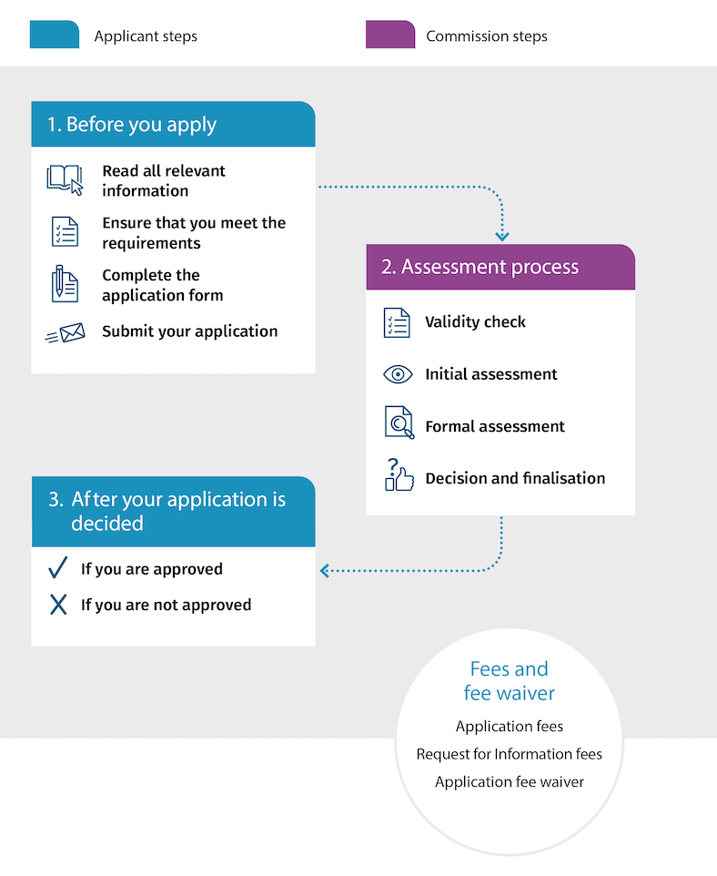



Part A:

Before you apply

Before you apply

The purpose of the application is to allow us to assess your suitability to provide aged care services.

Approved providers must deliver aged care that aligns with the responsibilities and standards outlined in the Aged Care Act, the Commission Act and the principles made under s. 96-1 of the Aged Care Act (the Principles).

You must understand what these responsibilities and standards are so that you can meet your obligations.

In your application, you must clearly demonstrate that you:

* can comply with aged care regulations
* have the necessary expertise and systems in place that will enable you to deliver quality aged care services to care recipients
* have effective financial systems in place to manage subsidies, and care recipients’ fees and payments.

If you cannot adequately tell us how you will do this, your application will not be approved.

Read all relevant information

Aged care legislation changes often. If you are approved to provide aged care, you will be expected to monitor any changes to aged care legislation and update your governance systems accordingly.

All applicants must read and understand the following information:

* [Guidance and Resources for Providers to support the Aged Care Quality Standards](https://www.agedcarequality.gov.au/providers/standards)
* [Commission Act and Rules](https://www.agedcarequality.gov.au/providers/commission-act-and-rules)
* [National aged care reforms](https://www.agedcarequality.gov.au/reforms)
* relevant aged care legislation and associated principles, including
* [Aged Care Act 1997](https://www.legislation.gov.au/Series/C2004A05206)
* [Quality of Care Principles 2014](https://www.legislation.gov.au/Series/F2014L00830)
* [User Rights Principles 2014](https://www.legislation.gov.au/Series/F2014L00808)
* [Accountability Principles 2014](https://www.legislation.gov.au/Series/F2014L00831)
* [Fees and Payments Principles 2014](https://www.legislation.gov.au/Series/F2014L00829).

If you are applying to provide home care, you must also read and understand:

* the [HCP program](https://www.health.gov.au/initiatives-and-programs/home-care-packages-program) support material developed by the Department of Health and Aged Care
* the [Serious Incident Response Scheme](https://www.agedcarequality.gov.au/reforms#serious-incident-response-scheme-sirs-expansion-into-home-services) for home care
* [Home services](https://www.agedcarequality.gov.au/providers/home-services).

If you are applying to provide residential care, you must also read and understand the following:

* [About accreditation](https://www.agedcarequality.gov.au/consumers/about-accreditation)
* [Serious Incident Response Scheme](https://www.agedcarequality.gov.au/sirs).

It is also recommended that you review information from the following external bodies to help you with the application process. Below are some helpful search words you can use on each website:

* [Australian Securities & Investments Commission (ASIC)](https://asic.gov.au/)
* your business
* directors and financial reporting requirements
* record keeping for small business
* responsibilities of company office holders
* [business.gov.au](https://business.gov.au/)
* business plan template and guide
* work health and safety industry, state or territory requirements
* [Office of the Australian Information Commissioner – privacy information](https://www.oaic.gov.au/)
* state and territory privacy regulation
* information about accessing documents held by Australian Government ministers and most agencies
* [Australian Federal Police](https://www.afp.gov.au/) and [FindLaw Australia](https://www.findlaw.com.au/default.aspx)
* Spent Convictions Scheme
* Crimes Act 1994, Criminal Code Act 1995
* [Fair Work Ombudsman](https://www.fairwork.gov.au/) (previously Fair Work Australia)
* awards and agreements
* National Employment Standards
* [Australian Health Practitioner Regulation Agency](https://www.ahpra.gov.au/) (AHPRA)
* AHPRA legislation
* [Australian Competition & Consumer Commission](https://www.accc.gov.au/)
* professional services
* franchising code of conduct.

Ensure that you meet the requirements

You must be a corporation

A corporation is a trading or financial corporation within the meaning of s. 51(xx) of the Constitution of Australia.

This means that you cannot become an approved provider under the Commission Act if you are a sole trader.

You must meet certain criteria

The responsibilities of an approved provider cover all aspects of care delivery, including obligations to care recipients and to the Australian Government. The Commission must consider the requirements in Part 7A of the Commission Act.

Your application will only be approved if you can demonstrate how and why your organisation meets these requirements. You must:

* establish that you are suitable to provide aged care as specified in the Commission Act
* understand an approved provider’s responsibilities under the Aged Care Act
* deliver care that aligns with the Principles.

Approved providers must continue to comply with these requirements at all times.

Also see Important requirements for all applicants.

Key personnel must be suitable to be involved in the provision of aged care

From 1 December 2022, an applicant must ensure that its key personnel are suitable individuals and consider the suitability matters when deciding who its key personnel will be. If approved, you will be required to consider their suitability at least once every 12 months and be reasonably satisfied that the person is suitable to be involved in the provision of aged care.

The people you engage to oversee your organisation’s governance and service delivery are important for us to consider when assessing your application because key personnel play a critical role in supporting the organisation and the delivery of safe and quality care and services

We must assess the suitability of your key personnel as this is required under the Commission Act and if any of your key personnel are not suitable individuals, your application will not be approved.

If you are approved certain key personnel will have a personal obligation under section 10A-1 of the Aged Care Act to notify you (as the provider and their employer) of a change of circumstances that relates to a suitability matter in writing within 14 days after becoming aware of the change. In practice this might mean giving notice to the governing body of the organisation, or the relevant manager within the service who is nominated to receive such notices

More information about this new requirement is available on the Commission website (see [Provider responsibilities relating to governance - Guidance for approved providers](https://www.agedcarequality.gov.au/resources/provider-responsibilities-relating-governance-guidance-approved-providers-draft-14-november-2022)).

Who are key personnel?

Your key personnel are the people in your organisation who will make decisions about how your organisation is run, including those who will be responsible for directing how care is delivered.

Key personnel are defined in s. 8B of the Commission Act as:

* people responsible for the executive decisions of the entity (this includes directors and board members)
* people having authority or responsibility for, or significant influence over, planning, directing or controlling the activities of the entity
* any person who is
* for an entity conducting an aged care service
* responsible for nursing services provided and who holds a recognised qualification in nursing
* responsible for the day-to-day operation of an aged care service conducted, or proposed to be conducted, by the entity, whether the person is employed by the applicant or not
* for a proposed aged care service
* responsible for nursing services provided and who holds a recognised qualification in nursing
* responsible for the day-to-day operation of an aged care service conducted, or proposed to be conducted, by the entity.

The above points apply whether or not the person is employed by the applicant.

We expect that your key personnel have the necessary skills and qualifications (where relevant) to perform their roles.

For example, key personnel responsible for financial management should have financial qualifications. Key personnel responsible for overseeing the delivery of clinical care or directing how care is delivered should have clinical qualifications and registrations.

We also expect that key personnel with clinical qualifications have roles that correspond with their scope of practice. For example, a clinical psychologist should not have responsibility for wound management or medication management.

Who is suitable to be involved in providing aged care?

Key personnel must:

* be fit and proper people; meaning they have the integrity, honesty and good reputation to make executive decisions or manage operational matters on behalf of the organisation
* have the experience, skills and qualities that make them appropriate leaders, as informed by the needs of the organisation and the skills required.

The experience of your key personnel may be broader than aged care or related care work. Experience in other sectors such as health delivery, hotel management, risk management, finance and law may also be relevant to your organisation. It is important in contemporary organisations that governing body members have complimentary skills, as relevant to their role and the objectives of the organisation

What are the suitability matters?

Section 8C of the Commission Act provides the meaning of suitability matters in relation to an individual, which is:

* the individual’s experience in providing, at any time, aged care or other relevant forms of care;
* whether a NDIS banning order against the individual is, or has at any time been, in force;
* whether the individual has at any time been convicted of an indictable offence;
* whether a civil penalty order against the individual has been made at any time;
* whether the individual is, or has at any time been, an insolvent under administration;
* whether the individual is or has at any time been the subject of adverse findings or enforcement action by any of the following:
* a Department of the Commonwealth or of a State or Territory;
* the Australian Securities and Investments Commission;
* the Australian Charities and Not-for-profits Commission;
* the Australian Competition and Consumer Commission;
* the Australian Prudential Regulation Authority;
* the Australian Crime Commission;
* AUSTRAC;
* another body established for a public purpose by or under a law of the Commonwealth;
* a State or Territory authority (including, but not limited to, a body that is equivalent to a body mentioned in subparagraphs (ii) to (vii));
* a local government authority;
* whether the individual:
* is, or has at any time been, the subject of any findings or judgment in relation to fraud, misrepresentation or dishonesty in any administrative, civil or criminal proceedings; or
* is currently party to any proceedings that may result in the individual being the subject of such findings or judgment;
* whether the individual is, or has at any time been, disqualified from managing corporations under Part 2D.6 of the Corporations Act 2001;
* any other matter specified in the rules

We will verify the information you provide to us in relation to your key personnel by undertaking a check of records held by the Australian Financial Security Authority, specifically the National Personal Insolvency Index, for all your proposed key personnel.

You must use the current application form

You must always use the relevant form from the [Commission website](https://www.agedcarequality.gov.au/providers/becoming-approved-aged-care-provider) at the time you submit your application.

You must use the current forms because they contain questions and information relevant to the care type you are applying for, and the latest legislative responsibilities and obligations for aged care.

Your application will be deemed invalid if we find that you:

* used an old form
* altered the application form
* failed to provide the specified supporting documentation with the application form.

We will let you know if your application is invalid and the reasons why.

You must pay an application fee

You must pay an application fee for us to assess your application. This fee is not refundable.

If you meet certain criteria, you may ask to have the application fee waived. See Fees and fee waiver.

When you pay the application fee, we will check whether we need further information from you to progress to the assessment stage.

Complete the application form

You must check that you have completed all relevant fields and answered all questions correctly. Your responses:

* must provide clear, detailed information that demonstrates your experience and suitability to deliver the type of care you are applying for
* must not be a reproduction of the knowledge or experience of an external organisation or person (such as a consultant) – your answers must be your own.

If you have used the services of a consultant, you must provide their details in the application form.

Your key personnel are responsible for the information provided in the application form, even if you are using an aged care consultant. This is because your key personnel will be responsible for the delivery of aged care services and compliance with the aged care regulatory framework.

Part B of this guide has more information about completing the application form.

If the information in your application is unclear or has gaps, we may need to request further information from you. There is a fee for each Request for Information sent to you (see Fees and fee waiver).

Submit your application

When you submit your application form, there are a few steps that need to be undertaken before we will start assessing your application (see next section).



Part B:

Assessment process

Assessment process

We follow a 4-stage assessment process to determine whether you will be approved as a provider.

Validity check

A validity check determines whether your application meets the requirements of s. 63B(2) of the Commission Act. This will take up to 5 business days.

To be valid, your application must be:

* made in writing
* made using the relevant and current form approved by the Commissioner
* accompanied by any documents or information specified by the Commissioner
* accompanied by any fee specified by the Commissioner.

If your application is valid, all documentation is attached and your application form is complete, we will send you an invoice to satisfy the final requirement, which must be paid before we start the initial assessment.

If your application is not valid, documentation is missing or you have not provided all responses in your application form, we will email you to tell you what is missing. Your application will not progress. At this stage, if you revise and resubmit your application, the process will restart.

You must provide any information to us within 10 business days. If you provide the information within the timeframe and we assess your application as valid, we will send you an invoice, which must be paid before we start the initial assessment.

If you have applied for an application fee waiver, we will check that your application is valid. If it is, we will review your waiver request and make a determination against the criteria for an application fee waiver. If your application fee waiver is approved, we will tell you and start the initial assessment. If your waiver is not approved, we will tell you and send you an invoice, which must be paid before we start the initial assessment.

We will confirm that we have received your application fee, and check the information provided in the form and the documents that you have attached. This process may take up to 10 business days.

If your application passes this stage, we will advise you in writing.

Initial assessment

The initial assessment is a more thorough check of your application to identify, for example, whether all additional documents identified by you are attached and contain the necessary information to assess your application. The initial assessment takes up to 10 business days.

We check your organisation’s records held with ASIC, and the ASIC records of all your key personnel, including company directors and board members.

If you provide care under another Australian Government–subsidised scheme, we also check your record of compliance with the relevant agency. This may include the Australian Charities and Not-for-profits Commission, or the NDIS Quality and Safeguards Commission.

If the information you have provided in your application is complete and we find no issues in our records checks, we will advise you in writing that your application has progressed to formal assessment.

If we need more information at this stage, we will send you a Request for Information (see Box 1) with an invoice. If you do not pay the fee, your application will be assessed based on the information you initially provided, and it may not be approved.

Box 1 What is a Request for Information?

This is a written notice issued to you as set out under s. 63C of the Commission Act.

A Request for Information will tell you what you need to provide so that we can continue assessing your application. This might include additional information about your key personnel, or missing information about your financial position. We may also ask you to clarify specific responses in the application form itself.

You must pay a fee for each Request for Information issued to you, unless we have approved a fee waiver. See Fees and fee waiver.

If you receive a Request for Information, you will have 28 days to provide the requested information. If necessary, you can ask us for a time extension. An extension must be requested in writing and be received before the end of the 28-day period.

If you do not provide the necessary information within the specified timeframe, your application will be automatically withdrawn as per s. 63C(5) of the Commission Act. We will let you know that this has occurred. We will take no further action on your application. If you still want to be an approved provider, you must reapply and pay another application fee.

If your application is withdrawn, either voluntarily or through s. 63C(5) of the Commission Act, you will not receive a refund of the application fee or Request for Information fee.

Important

Make sure your responses and documents are clear and concise, and that you have provided accurate and sufficient information to allow us to assess your suitability, including how you will operate your service.

Formal assessment

We will email you if your application passes the initial assessment stage and moves to formal assessment. The formal assessment takes up to 90 days.

The formal assessment stage is a full assessment of your application against the suitability matters established under s. 63D of the Commission Act. A senior assessor will review your application and all supporting documentation, and draft a recommendation to the delegate.

If more information is needed, we will send you a Request for Information (see Box 1) with an invoice. If you do not pay the fee, your application will be assessed based on the information you initially provided, and it may not be approved.

The 90-day timeframe for formal assessment starts when we inform you that your application has moved to the formal assessment stage. If we issue a Request for Information, the timeframe stops and will resume when we receive the information.

Decision and finalisation

The delegate will consider the senior assessor’s recommendation, discuss it with the senior assessor, if necessary, and decide the outcome of your application.

We will send you a written decision within 14 days of the decision being made, in accordance with s. 63E of the Commission Act.

After your application is decided

If you are approved

If you are approved, we will send you a written notice with important information about your approval and other steps you may need to take, depending on the care type you are approved to deliver.

Quality and compliance monitoring

Approved providers have notification responsibilities to the Australian Government Department of Health and Aged Care and the Commission. You must participate in quality reviews and compliance monitoring assessments. You must continue to meet your obligations under the Aged Care Act to retain your approval to provide Australian Government–subsidised aged care.

You should maintain your understanding of an approved provider’s responsibilities after you are approved. You must implement and maintain the systems you said you would have in place so that you can comply with these responsibilities.

If you do not comply with your notification responsibilities, you may be found to be noncompliant and you may be subject to compliance action.

You must tell us if anything changes

Under section 9-1 of the Aged Care Act, you must tell us about any change of circumstance that materially affects your suitability to provide aged care (see Part 7A of the Commission Act). You must do this within 28 days of the change.

You can download the [Notification of a Material Change form](https://www.agedcarequality.gov.au/providers/notifying-material-changes-approved-providers) from the Commission’s website.

You must keep your contact details up to date

We sometimes need to contact you to provide important information about aged care. It is important that you keep your contact details up to date.

To update the contact details for your home care service, use the [Home Care Service](https://forms.business.gov.au/smartforms/servlet/SmartForm.html?formCode=PRD00-HCSN) [Notification form.](https://forms.business.gov.au/smartforms/servlet/SmartForm.html?formCode=PRD00-HCSN)

To update the contact details in your approved provider record, use the [Notification](https://www.agedcarequality.gov.au/providers/notifying-material-changes-approved-providers) [of a Material Change form](https://www.agedcarequality.gov.au/providers/notifying-material-changes-approved-providers).

Important

If you update your contact information in the My Aged Care portal, it does not automatically flow through to your approved provider record. You must use either the Home Care Service Notification form or the Notification of a Material Change form.

Your approval can be revoked

We can revoke or suspend your approval at any time if you breach the requirements or are found to be noncompliant.

Reasons for revoking your approval may include:

* your application for approval contained misleading information
* you cease to be a corporation
* you cease to be suitable for approval.

Next steps after approval

Once you have been approved, you need to take further steps before you can deliver aged care services. These steps depend on the care type you are approved to provide.

The steps you need to take will be outlined in your approval notice, but the following information may help.

Home care services

You must use the [Home Care Service Notification form](https://forms.business.gov.au/smartforms/servlet/SmartForm.html?formCode=PRD00-HCSN) to notify the Secretary of the Department of Health and Aged Care about each home care service(s) that you intend to deliver care from. You must submit this form before you can claim a subsidy for home care services.

You must complete a separate form for each home care service you open. A service is defined under the Aged Care Act as ‘an undertaking through which home care is provided’.

This step is required under s. 9-1A of the Aged Care Act. You must provide:

* the name and address of the service
* any other information specified in the Principles.

Residential aged care services

In the past, approved residential care providers were allocated places through the Aged Care Approvals Round (ACAR), or through a transfer of places from an approved provider.

As of 30 July 2021, the ACAR is no longer operating.

Instead, from 1 July 2024, residential aged care places will be allocated directly to senior Australians. This provides more choice and control about which approved provider delivers their care.

New and existing providers will no longer need to apply for and be allocated places. This gives you greater freedom to adjust and expand your service offerings and improve the way you meet demand.

During the transition period between 1 July 2021 and 1 July 2024, there will be 2 ways to seek an allocation of residential places:

* Providers can come to an arrangement with another provider to acquire places that are excess to their requirements and seek approval from the Department of Health and Aged Care to transfer these places.
* Alternatively, on completion of requisite building works, providers that can demonstrate they are in a position to provide care will be able to seek an allocation of places through a non-competitive process.

More information is available on the [Department of Health and Aged Care website](https://www.health.gov.au/initiatives-and-programs/improving-choice-in-residential-aged-care).

Listing on My Aged Care

After you have been approved, you will need to register with [My Aged Care](https://www.myagedcare.gov.au/).

You can register online, view fact sheets and frequently asked questions, take a My Aged Care system overview, and find guides and videos.

Information is also available on the [Department of Health and Aged Care website](https://agedcare.health.gov.au/node/36356).

If you are not approved

If the delegate decides not to approve your application, we will send you a statement of reasons. It will let you know why your application was not approved and tell you what your review rights are.

If you are not satisfied with the decision, you can:

* reapply and pay a new application fee
* ask the Commissioner to reconsider the decision.

Reapplying

If you choose to reapply, you must complete a new application form and pay the application fee.

Before you start a new application, you should reflect on the reasons that your previous application was not approved, which will be detailed in the notice.

In your new application, you should address any deficiencies that were identified and consider reviewing your methods for delivering aged care and services.

Reconsiderations

You can ask us to reconsider a decision not to approve your application. If you request a reconsideration, you must:

* make the request in writing within 14 days of receiving the decision
* tell us why you are making the request
* address specific areas that we identified as reasons for non-approval
* add any additional evidence or identify previously submitted evidence you would like to have considered

Applications for reconsideration are to be submitted to[reconsideration@agedcarequality.gov.au](mailto:reconsideration@agedcarequality.gov.au)using ‘*Director Reviews and Reconsiderations – request for reconsideration under s74K of the Commission Act*’ in the email subject.

When we act on this request, a different delegate from the one who made the original decision will be responsible for the reconsideration decision.

Reconsiderations are dealt with under Part 8B of the Commission Act. The Commissioner can also reconsider a decision made under subsection 63D(3) of the Commission Act if they are satisfied that there is sufficient reason to do so.

The possible outcomes of reconsideration are:

* we confirm the original decision
* we vary the original decision
* we set the original decision aside and substitute a new decision.

If we do not make a determination within 90 days, the original decision is confirmed.

Request a reconsideration by the Administrative Appeals Tribunal

If the original decision is confirmed and you are not satisfied with the reconsideration decision, you may seek a review by the Administrative Appeals Tribunal.

You must:

* apply in writing
* apply within 28 days of receiving the decision
* pay the Administrative Appeals Tribunal application fee.

For more information, see the [Administrative Appeals Tribunal website](https://www.aat.gov.au/apply-for-a-review/other-decisions/how-to-apply) or phone 1800 228 333.

Fees and fee waiver

Section 23 of the Commission Act sets out requirements for the charging of fees for services provided by the Commission to perform its functions.

Any fees you pay during the approval process are not refundable, even if you withdraw your application or you are not approved.

Application fees

When you submit your application and we deem it to be valid, we will send you an invoice within 10 business days. The invoice will include the amount you need to pay and how to pay it.

The amount payable depends on the care and services you are seeking approval to provide. You will have 28 days to pay the fee. The application process will not start until you pay the fee.

If you do not pay the fee, your application will not progress.

Application fees

|  |  |  |
| --- | --- | --- |
| **Application type** | **Description** | **Fee** |
| Single care type | Application for approved provider status for one care type (e.g. home care only). Applicants may be new or existing approved providers. | $9,070 |
| 2 care types | Application for approved provider status for 2 care types (e.g. home care and residential care). Applicants may be new or existing approved providers. | $10,530 |
| 3 care types | Application for approved provider status for all care types (home care, residential care and flexible care). New applicants only. | $12,270 |
| Government organisation | Government organisations (specifically states, territories, authorities of a state or territory, and local government authorities) are approved to deliver all types of aged care. They do not have to be assessed, but they do need to register for approved provider status. They do not pay an application fee. | $0 |

Request for Information fees

If you fail to fully outline your suitability to provide aged care services and we need more information, we will send you a Request for Information (see Box 1). The following additional fees will apply.

Request for Information fees

|  |  |  |
| --- | --- | --- |
| **Request for Information type** | **Description** | **Fee** |
| Pre-assessment | Only payable when the application does not have the necessary information to allow it to progress to assessment, such as missing pages in documents or missing information about key personnel. | $235 |
| Initial assessment request – single care type | Only payable when you have been asked to provide further information to allow us to make a decision – for example, if we request more information to substantiate your claims of suitability. | $1,170 |
| Initial assessment request – 2 care types | $1,430 |
| Initial assessment request – 3 care types | $1,760 |
| Subsequent assessment request – single care type | $490 |
| Subsequent assessment request – 2 care types | $585 |
| Subsequent assessment request – 3 care types | $740 |

Application fee waiver

You can apply to have your application fee waived if you are seeking approval to provide residential care, home care or flexible aged care and services that meet all of the following 3 conditions:

* You intend to provide at least 85% of care and services to care recipients located in [Modified Monash Model](https://www.health.gov.au/health-topics/rural-health-workforce/classifications/mmm) (MMM) areas 6 and 7 – regions that are remote or very remote.
* You can provide strong evidence of the above intention.
* You include detailed information about the services you intend to provide in these remote or very remote areas.

If you believe you meet these conditions, complete an [Application Fee Waiver Request form](https://agedcarequality.govcms.gov.au/media/90970) and submit it with your application form. We will cross-check the information in both forms.

You must provide evidence of as many of the following as possible:

* the rental or ownership of an administrative or business location within the relevant MMM area
* a recruitment strategy for staff within the relevant MMM area
* advertising or promotion of services within the relevant MMM area
* memorandums of understanding with communities or community groups from within the relevant MMM area
* representation on the organisation’s board or advisory body of people from the relevant MMM area
* involvement of key personnel from the MMM area
* a history of relevant service provision in the relevant MMM area
* evidence of demographic studies or service demand studies within the relevant MMM area
* corporate documents stating organisation goals and target locations or populations within the relevant MMM area
* references from members of target communities within the MMM area.

If you are seeking approval to provide residential care services and/or flexible care in a residential care setting, you also need to provide evidence of your facility’s location within one or more MMM 6 or 7 areas.

We will assess the information you provide to us and send you the outcome of the assessment in writing within 10 business days.

If your application fee waiver is approved, any fees relating to a Request for Information will also be waived (see Box 1).

If your request for a waiver is not approved, you will receive a statement of the reasons why. This decision is not reviewable. You will also receive an invoice for the application fee, which must be paid within 28 days. If you choose not to proceed with the application at this point, you must let us know.



Part C:

Completing the application form

General guidance

Part B of this guide provides an overview of the sections in each form, with more detail and instructions within the forms themselves:

* [new applicants](https://www.agedcarequality.gov.au/media/87218)
* [existing approved providers](https://www.agedcarequality.gov.au/media/87219)
* [government form](https://www.agedcarequality.gov.au/media/87220).

With the exception of the Government form, the aim of the application is to allow us to assess your suitability to be an aged care provider. We need to know details about what you will do, how you will do it and who will be involved.

You must demonstrate that you are suitable to provide the type of aged care you are applying for, even if you are already approved to provide a different care type. Under subsection 63D(3) of the Commission Act, we must consider:

* your experience in providing aged care or other relevant forms of care
* your understanding of your responsibilities as an approved provider
* the systems you have or will have in place to meet these responsibilities
* your record of financial management and the methods used, or proposed, to ensure sound financial management
* your previous conduct as an approved provider of aged care or any other form of care, your compliance with the relevant responsibilities and your compliance with your obligations relating to any Australian Government payments you received for providing that care.

Any other matters specified in the Principles may also be considered.

The Commission can consider most of these matters when assessing the suitability of your key personnel, except the systems in place or proposed. The Commission is not limited to considering only the suitability matters when deciding whether you are suitable to provide that care.

To help us assess your suitability, your responses in the application form should be clear, and relate to the question asked and the relevant legislative responsibilities.

The application form should be completed by key personnel who have knowledge of the organisation. If you use a consultant to help prepare your application, you are responsible for the information provided and the responses must be your own.

Helpful tips for completing the application form

| **Do** | **Don’t** |
| --- | --- |
| Use the current form on the Commission website at the time you submit your application.   * Check that the application form you completed is the same as the published version. | * Use an old form. * Alter the current form in any way unless instructed by us. Forms that are altered without following instructions will be invalid, and your application will not proceed. |
| Give your own responses and information, not that of another approved provider, a consultant or an unrelated third party.   * The application assesses **your** suitability and knowledge of aged care legislation and the delivery of quality aged care services, not someone else’s. | * Copy and paste excerpts from legislation. This does not give us any insight into whether you understand the legal requirements or what they mean. * Copy and paste excerpts from guidance materials from the Commission, the Department of Health and Aged Care or any other aged care organisation. * Copying information from someone else does not tell us how you will deliver your services. * Rely on a third party’s documentation or understanding of aged care legislation. |
| Be clear and provide accurate explanations about your processes and policies.   * It is up to you to tell us how, what, when, where and why in a way that is easy to understand and that addresses every question that is asked. * Be specific and tell us how your stated policies and procedures will operate in practice. * Include attachments to support your claims, and make sure you specify which part of the policy is relevant to the question being asked in the application form. | * Provide a list of policies and procedures – this does not provide enough detail about their content. * Insert sections or whole copies of your policies and procedures into the application form. You can include these as attachments. * Provide copies of your policies, procedures or operating manual without directing us to the specific section that is relevant to the question asked and the information in your response. * Provide generic documents that are not tailored to the environment you intend to operate in or that do not reflect your organisation’s governance or systems. |
| Proofread your responses, and make sure they make sense and are supported by any documents you submit. | * Cite legislation if it is not relevant to the question asked, or relates to other care and services you provide (such as under the National Disability Insurance Scheme). * Provide responses that do not relate to the care type you are applying for. |
| Submit your application and any attachments in PDF, Word or Excel format, with a maximum file size of 10 MB. | * Provide links to cloud services such as Dropbox or Google Drive. * Send an email attachment that is greater than 10 MB, as it may not be received. |

Application checklist

This checklist helps you to identify the documents that you need to submit with your application form.

It also provides space for you to list any other supporting documents that you have attached as evidence of your suitability, or to support any of the responses you provide in the application form.

Key personnel declaration

You must sign and date the key personnel declaration on the application form; otherwise it will be invalid.

There are penalties for giving false or misleading information. Make sure you have read the content of the declaration carefully and understand the implications if you do not meet any of the requirements.

Section 1 – About the applicant

All 3 application forms contain sections that seek information about your organisation. The requested information varies depending on the type of applicant.

This is where you must tell us who you are and submit your business registration certificate. You must give us your contact details and the contact details of any consultants involved in this application. You must tell us what care type you are applying for and what type of organisation you have (e.g. for profit or not for profit – see the appendix in the application form for more details).

If you are an existing approved provider, this is where you provide new information about your organisation so that we can update your approved provider record.

Example business registration certificate



Corporate structure

You must attach a copy of your organisation chart or diagram of your organisation structure.

Please make sure it clearly and accurately reflects how your organisation is structured and identifies all people with responsibility for operating your organisation.

If you have vacant positions, clearly state your process for filling the vacancy and any measures you will implement to ensure that the responsibilities for that role are delivered in the meantime.

Business plan

You must attach a copy of your business plan. It should outline the business goals and detail how you will achieve them. It should be accurate and a true reflection of your business.

Do not submit a business plan that does not include your proposed new aged care service offering. We will consider your suitability to be an aged care provider only, not your plans for operating other government-subsidised services such as the National Disability Insurance Scheme (NDIS).

Use of another organisation (subcontract arrangements)

You must tell us if you currently have, or propose to enter into, an agreement with another entity to deliver care and services on your behalf. For example, you may use the services of a management company, or a nursing service that will deliver clinical services on your behalf.

You must provide details of that organisation, including their contact details, roles and responsibilities. We ask for this information to understand your business model, how you intend to operate and your understanding of an approved provider’s responsibilities for oversight of another organisation.

It will be recorded in the approved provider record if you are approved because it is relevant to the governance of your aged care services.

Because you are responsible for making sure that all outsourced care and services meet your obligations and responsibilities as an approved provider, you must tell us:

* how you will actively oversee the delivery of outsourced care
* who in your organisation is responsible for oversight of the other entity
* what actions you will take to ensure that care is delivered in compliance with the Aged Care Act and the Principles.

You must also attach a copy of the agreement between you and the other entity. The agreement should include clauses explaining how:

* the other entity will deliver care and services in a way that complies with the obligations and responsibilities of approved providers under the Aged Care Act
* you will access the services and be informed about the delivery of services, at any time, to enable you to comply with the obligations and responsibilities of an approved provider under the Aged Care Act
* you will ensure continuity of care and service delivery in accordance with the provisions of the Aged Care Act and the Principles.

Section 2 – Your key personnel

See Part A of this guide for a definition of key personnel and suitability of individuals. The application form also includes examples of key personnel.

You must complete a ‘KP Individual Detail’ section for each of your key personnel and provide their personal details, qualifications and relevant experience. Each key personnel check that the information about them is correct and sign the declaration at the end of their section.

You must provide a police check or an NDIS Worker Screening Check and an insolvency check for each key personnel, and a statutory declaration. See details in the application form.

Under Part 7A of the Accountability Principles 2014, you must record the matters you considered when determining that each of your key personnel was a suitable individual. You must take reasonable steps to ensure that your key personnel are suitable and are not disqualified individuals. You must understand and implement this requirement at the time of applying and, if approved, throughout the time you are an approved provider.

Example national police check report

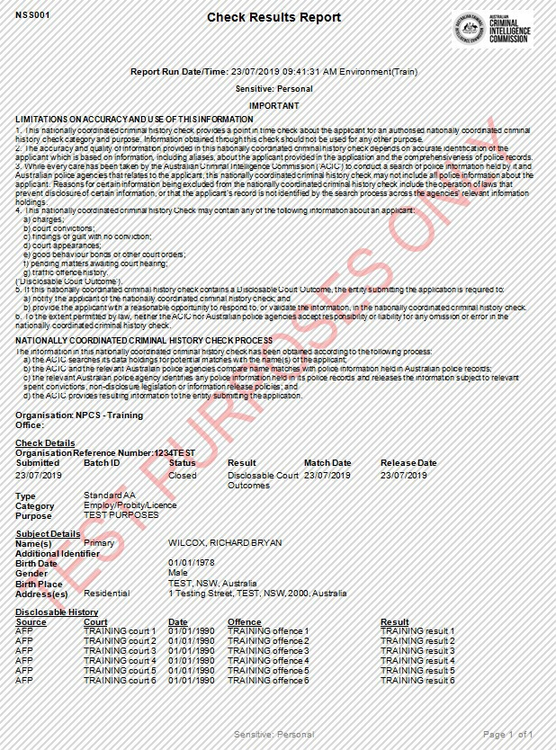

Example insolvency check report

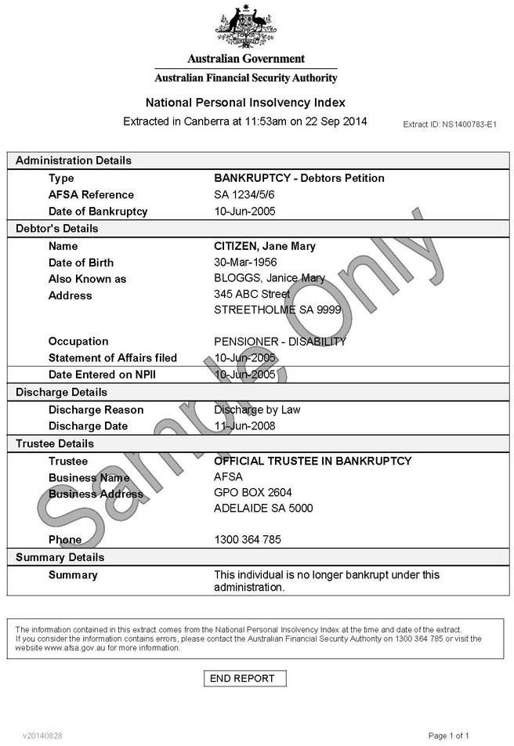

Section 3 – Your suitability to be an approved provider

The information you provide in this section must be a true and accurate representation of you and your key personnel’s knowledge about delivering aged care and services that comply with aged care legislation.

If you have used the services of a consultant to complete the application form or write your policies and procedures, or if you have purchased a suite of policies and procedures, we need to know that you can put this information into your daily operations, and actively review and adapt to ensure that you maintain compliance.

Even if you are an existing approved provider, you still need to give us details about how you will integrate the requirements of the new care type into your existing operations.

Experience, conduct and compliance

When assessing your experience and the experience of your key personnel, we consider whether that experience is transferable to the delivery of the care type(s) that you have applied for.

New applicants should provide enough detail to give us a clear understanding of the care you have delivered, including any care you may have delivered on behalf of another organisation.

If you have provided care on behalf of an approved provider, you should tell us about your agreement with them and who they are.

If you are an existing approved provider, you may also choose to tell us about the aged care you deliver, or any other form of care you deliver. You will be asked to tell us about any new key personnel you have engaged to manage the new care type you are applying for.

Whether you are a new applicant or an existing approved provider, you must tell us about your compliance with aged care regulations, or any other regulatory framework you were or are subject to. This may include providing services under the NDIS, childcare or family daycare, or the Department of Veterans’ Affairs.

We will check other government compliance registers, including the NDIS Quality and Safeguards Commission compliance register, where relevant.

If you are, or have been, an approved provider or provided Commonwealth Home Support Programme services, we always review the Commission’s internal compliance activity for all existing approved providers. However, this does not remove your responsibility to inform us about this in your application.

If you have been subject to compliance activity, and you have not provided sufficient information to help us determine your ability to effectively manage noncompliance, or we have concerns about your ability to be compliant, we may seek further information from you.

Governance systems

The Commission must assess your systems for providing the care type you are applying for. The systems you implement are the cornerstone of an effective approved provider.

You should demonstrate that you have appropriately planned for and identified the different structures to ensure that the decisions you make are aligned with the responsibilities of an approved provider and that your decision makers are held accountable.

You should establish how your systems effectively integrate and support the delivery of quality aged care services.

Your responses should be clear and concise. When responding to the questions in this section, consider:

* how your systems will support the delivery of quality aged care and services
* who within your organisation is directly responsible for each of your governance systems
* how and why your systems will support you to comply with the responsibilities of an approved provider
* any off-the-shelf systems you have purchased, or intend to purchase, and what due diligence you have undertaken to ensure that they support compliance.

Do not provide a simple list of policies and procedures. You need to explain how your policies and procedures support compliance.

If any of your systems have been independently assessed, attach a copy of your most recent audit to confirm the effectiveness of your systems; for example, an NDIS audit report that outlines the audit undertaken and the findings of the auditor.

Financial management

You need to tell us about the way you manage your finances and your methods for managing government subsidies.

Aged care legislation has specific requirements, which are set out in the Aged Care Act and the Principles. For example, the Fees and Payments Principles 2014 and the User Rights Principles 2014 set out the collection of fees, the prudential responsibilities of residential care providers, and the pricing transparency responsibilities of home care providers.

You should be familiar with this legislation before you respond to this part of the application form. You need to thoroughly consider these responsibilities as they relate to the care type you are applying for, and explain how your financial management systems will maintain compliance with them.

It is useful if you provide an example of how your systems will operate every day and how you will implement them if they are not already in place.

The person you identify as being responsible for the financial management of your organisation should have the necessary skills, qualifications and experience to support compliance with an approved provider’s financial management responsibilities.

Similarly, your financial capacity and viability are an important part of sound financial management.

You need to explain the working capital and funding you have available to start delivering aged care services. You need to clearly establish that you are prepared for the costs associated with delivering aged care and services. Explain how you will do this or outline the key strategies you have identified in your financial plan.

Responsibilities as a provider – quality of care, user rights and accountability

An approved provider’s responsibilities are established under the Aged Care Act and the Principles. You should be familiar with Parts 4.1, 4.2 and 4.3 of the Aged Care Act before you complete your application.

This legislation also specifies the related Principles, such as the Quality of Care Principles 2014 (incorporating the Aged Care Quality Standards), the User Rights Principles 2014 and the Accountability Principles 2014.

Your understanding of these responsibilities goes together with your ability to develop systems, policies and procedures that will be compliant. The questions in the application form are designed to help you to tell us how you would meet the responsibilities that relate to the care type(s) you are seeking approval for.

You and your key personnel must have a practical understanding of these responsibilities, and be able to effectively monitor, review and update your systems when legislation changes.

Both new applicants and existing approved providers must demonstrate that they understand these responsibilities.

Governance arrangements

Amendments to the Aged Care Act have introduced specific responsibilities for certain approved providers in relation to their governance arrangements. These responsibilities are aimed at ensuring providers have the right leadership and culture, and that the organisation is transparent and accountable, all the while focusing on consumer wellbeing, safety, choice, and quality of life.

These responsibilities relate to the membership of governing bodies, the establishment of advisory bodies, and other related responsibilities (as set out in this document) which are intended to improve oversight and transparency and ensure that the focus of approved providers is on the best interests of consumers.

Your responses should demonstrate that you understand an approved provider’s responsibility for providing that specific care type, have developed systems, policies and procedures to be compliant.

Both new applicants and existing approved providers must demonstrate that they understand these responsibilities.

For more detailed information, see the [*Provider responsibilities relating to governance – Guidance for approved providers*](https://www.agedcarequality.gov.au/resources/provider-responsibilities-relating-governance-guidance-approved-providers) on the Commission website. This guidance provides an overview of key approved provider responsibilities in relation to governance.

Section 4 – Your ability to meet care type specific matters

This part of the form is separated into the 3 different care types. You only need to complete the section that is relevant to the care type(s) you are applying for.

Each of the 3 care types has requirements for an approved provider that only relate to that specific care type. For example, home care providers have several responsibilities that are different from those for a residential care provider.

Your responses should demonstrate that you understand an approved provider’s responsibility for providing that specific care type, and have developed systems, policies and procedures to be compliant.

Completing the Government form

This form was developed to allow a Government organisation to provide us with only the necessary information for us to create an approved provider record, record who your key personnel and relevant contacts are and allow subsidies to be claimed and paid.

Although a government organisation is deemed to be approved, you are still bound by the legislated responsibilities of an approved provider. This includes matters that relate to your key personnel.

The Government form asks about the people in your organisation who have decision-making responsibilities, but not the aged care services you provide.

You must ensure that your key personnel are suitable individuals and you are asked to provide evidence to confirm that certain suitability matters under section 8C of the Commission Act have been actively confirmed, and that you have taken all the steps required under the *Accountability Principles 2014* in relation to your key personnel.

If any part of the Government form is incomplete or you do not attach the identified documents, we will send the form back to you to action.