

**Aged Care Quality and Safety Commission - Stakeholder Engagement Strategy**

**2023-2025**

**Updated September 2024**

In the spirit of reconciliation, the Aged Care Quality and Safety Commission acknowledges the Traditional Custodians of the Country throughout Australia and their connections to land, water and community.

We pay our respects to their Elders past, present and emerging and extend that respect to all Aboriginal and Torres Strait Islander peoples.

The Stakeholder Engagement section can be contacted by emailing: engagement@agedcarequality.gov.au

**CONTENTS**

1. Stakeholder Engagement Strategy Overview 4

Introduction 5

Background 5

Objectives 6

Objective 1: Ensure that older Australians accessing aged care are at the centre at all times. 6

Objective 2: Uplift the Commission’s Engagement Capability 6

Objective 3: Respect Stakeholder Knowledge and their Needs 7

Objective 4: Improve Engagement Governance 7

2. Strategic Framework 7

Dependencies 7

Principles 8

3. Engagement Framework 8

4. Evaluating Success 10

5. Appendix 1 – External Stakeholder Map 11

# Stakeholder Engagement Strategy Overview

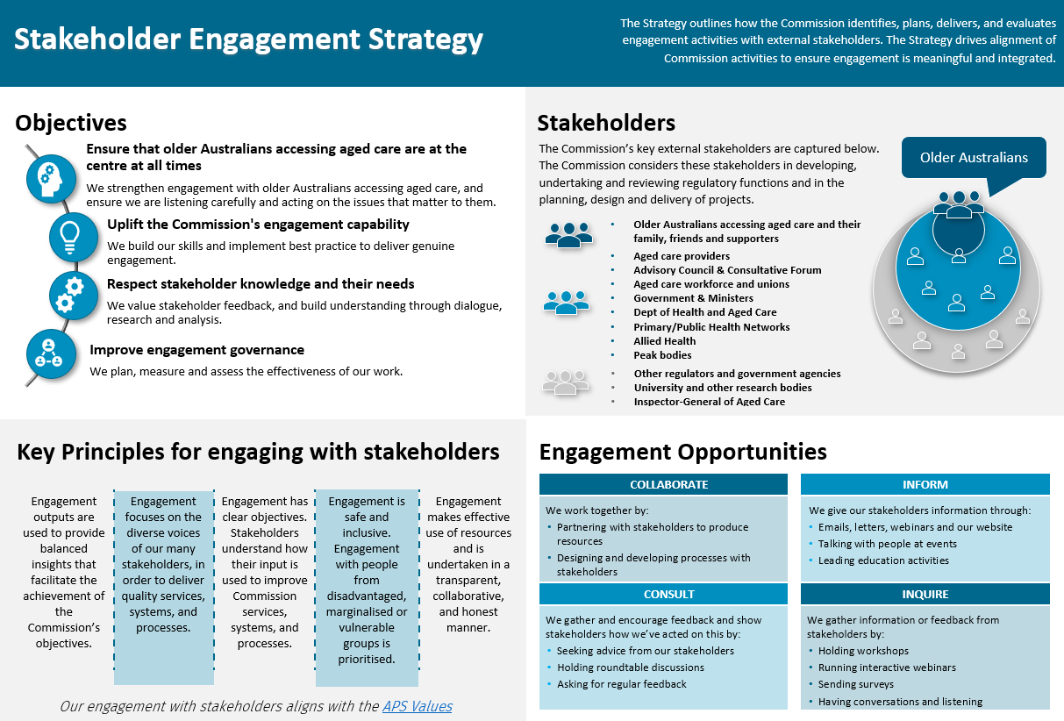

## Introduction

Engagement and collaboration with stakeholders underpin best practice regulation. Contemporary regulatory frameworks highlight the need for:

*‘Collaboration with stakeholders across the regulatory environment to foster innovation, continuous improvement and clear lines of responsibility and accountability’*

**Department of Health,** [**Concept Paper**](https://www.health.gov.au/sites/default/files/documents/2022/02/concepts-for-a-new-framework-for-regulating-aged-care.pdf)**: Concepts for a framework for regulating aged care**

Engagement also underpins the Aged Care Quality and Safety Commission’s Regulatory Strategy and Corporate and Operational Plans, with collaboration and consultation as core Commission functions.

The purpose of the Commission’s Stakeholder Engagement Strategy (the Strategy) is:

* to articulate how the Commission identifies engagement opportunities and then plans, delivers, monitors and evaluates engagement activities with external stakeholders; and
* to determine how insights from stakeholder engagement can effectively and efficiently inform the work of the Commission.

## Background

*‘Collaboration and consultation with key aged care stakeholders is a core function of the Commission [and] is vital in shaping how we work as a regulator and where we focus our efforts […]. These important relationships support us to learn, share expertise and information, influence provider behaviour, and directly inform our regulatory strategy and how we carry out our functions. Our ability to listen, hear and respond is central to delivering on our purpose. We recognise that this is an area where we need to do more, and we will more actively engage with all our stakeholders’*

**Aged Care Quality and Safety Commission Corporate Plan 2022-2023**

The Commission’s Statement of Intent also recognises that meaningful engagement and collaboration with stakeholders underpin best practice regulation. The Statement articulates the Commission’s desire for productive relationships with those receiving aged care, those providing aged care, and other key stakeholders, in order to effectively deliver its functions, and support the implementation of the Government's significant aged care reform agenda.

This Strategy is focussed on delivering strong stakeholder relationships that advance the Commission’s purpose and vision to be a world class regulator. We acknowledge the legislative importance of the Commission’s role in holding providers to account for the quality and safety of aged care services and to meet their financial and prudential responsibilities and broader regulatory commitments.

The Commission’s leadership team was consulted in the development of this strategy.

## Objectives

The Strategy outlines how, against the backdrop of a rapidly evolving sector, and strategic drivers including regulatory reform and other government programs, the Commission will identify opportunities to, plan, deliver and evaluate engagement activities with external stakeholders. The Strategy aligns related activities across the Commission’s functions to ensure engagement is strategic and integrated.

*‘Stakeholder engagement helps to ensure that regulations focus on user needs by involving citizens, businesses, civil society and others. These stakeholders can provide expertise and evidence about policy problems and possible solutions to address them, thereby improving the quality of regulatory design. Stakeholder engagement also makes regulations more inclusive and helps affected parties develop a sense of ownership of regulations. This in turn strengthens trust in government, social cohesion and compliance with regulations.’*

**OECD,** [**Government at a Glance,**](https://www.oecd-ilibrary.org/sites/c4f013c0-en/index.html?itemId=/content/component/c4f013c0-en#:~:text=Stakeholder%20engagement%20helps%20to%20ensure,the%20quality%20of%20regulatory%20design.) **Stakeholder engagement for developing regulations**

The Strategy aims to achieve the following objectives:

## Objective 1: Ensure that older Australians accessing aged care are at the centre at all times.

*We strengthen engagement with the people accessing aged care and ensure that we are listening carefully and acting on the issues that matter to them.*

* Older Australians, their families, friends, supporters and the public are aware of what should be expected of quality aged care and services.
* Older Australians are engaged and empowered in their care and can easily make complaints or provide information about their experience.
* The experience of care recipients informs our regulatory activities.
* Engagement is embedded into Commission activities and staff have the capability to engage effectively.

## Objective 2: Uplift the Commission’s Engagement Capability

*We build our skills and implement best practice to deliver genuine engagement.*

* Ensure the Commission maintains and strengthens its stakeholder relationships and supports the delivery of consumer-centric outcomes.
* Continues to identify and expand engagement across a broader range of stakeholders.
* Support the Commission in engagement opportunities.
* Incorporate culturally sensitive best practice methodologies of consultation to enhance the quality of engagement across different populations.

## Objective 3: Respect Stakeholder Knowledge and their Needs

*We value stakeholder feedback, and build understanding through dialogue, research, and analysis.*

* Map and monitor engagement activities to understand stakeholder touchpoints across the Commission’s functions.
* Ensure that information sourced from aged care related complaints provides a valuable source of intelligence.
* Use the outcomes from the customer experience project to inform engagement activities.

## Objective 4: Improve Engagement Governance

*We plan, measure, and assess the effectiveness of our work.*

* Establish meaningful performance measures for ongoing/regular engagement activities and the Strategy overall.
* Systematically record how engagement activity outputs and insights are translated into improvements and changes in Commission services, systems, and processes.
* Report against relevant performance measures.
* Ensure mechanisms to stakeholder feedback and insights are integrated into business processes and project deliverables.

The Strategy is supported by an Operational Plan that the Stakeholder Engagement Section drives in partnership with business areas across the Commission.

# Strategic Framework

## Dependencies

The Strategy is underpinned by the Commission’s:

* Corporate Plan
* Regulatory Strategy
* Financial and Prudential Strategy

The Strategy is informed by:

* Australian Public Service Framework for Engagement and Participation
* Other government initiatives such as Closing the Gap and the Commission’s Reconciliation Action Plan. In particular, the targets and priorities specifically relating to involving First Nations peoples in decision making and consultation are used to inform our engagement activities.

## Principles

The APS Values provide the principles for engaging with stakeholders, with engagement being:

* Impartial: Engagement will be used to provide balanced insights to business lines, to facilitate the effective achievement of the Commission’s objectives.
* Committed to Service: Engagement focuses on highlighting the diverse voices of our many stakeholders to design quality processes and services.
* Accountable: Engagement is underpinned by clear objectives. Engagement outputs and impact will be communicated back to stakeholders to demonstrate how their input has been used to improve Commission services, systems, and processes.
* Respectful: Engagement is safe and inclusive. We maintain a focus on engagement with people from disadvantaged, marginalised or vulnerable groups.
* Ethical: Engagement makes effective use of resources and is undertaken in a transparent, collaborative and honest manner.

# Engagement Framework

A core component of the Strategy is the establishment of an engagement framework. The Commission’s Stakeholder Engagement Framework is captured in *Figure 2* and draws on the International Association for Public Participation (IAP2 International) Public Participation Spectrum. In relation to the Spectrum, the definition of ‘public’ applies to all Commission stakeholders.

*The IAP2 Public Participation Spectrum is designed to assist with the selection of the level of participation that defines the public’s role in any community engagement program. The Spectrum show that differing levels of participation are legitimate depending on the goals, time frames, resources and levels of concern in the decision to be made. However, and most importantly, the Spectrum sets out the promise being made to the public at each participation level. The Spectrum is widely used and is quoted in most community engagement manuals.*

**IAP2 International**

Under the engagement framework there are four types of engagement, and a range of tools (see Table 1) that facilitate effective interactions with external stakeholders. Engagements that *Inform* use one way engagement to educate external stakeholders. Engagements that *Inquire* use limited two-way engagement to acquire information or feedback from stakeholders. Engagements that *Consult* use two-way or multi-way approaches to gather and encourage feedback and indicate to participants how feedback will be acted on. Engagements that *Collaborate* use two-way or multi-way communication enabling working together with stakeholders to produce joint outputs or achieve outcomes.

**Figure 2: Engagement Framework**

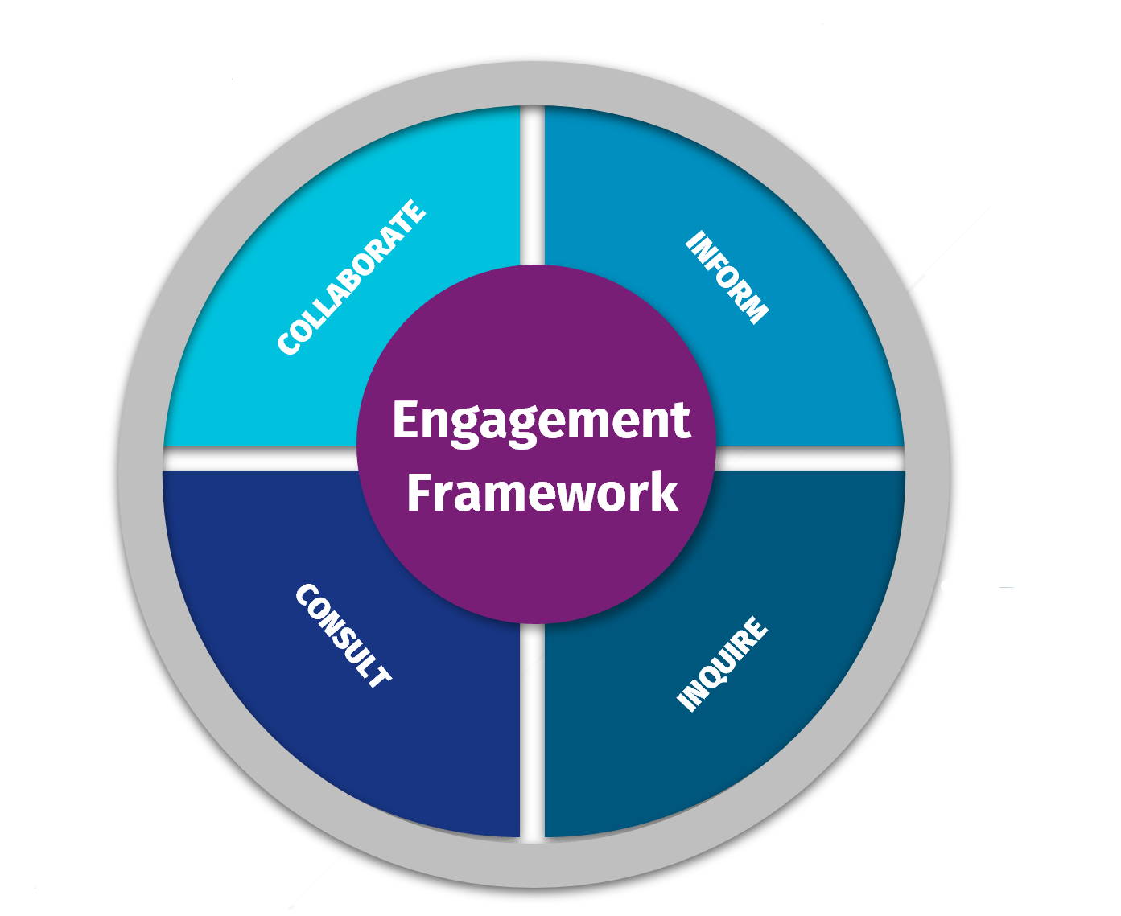

**Table 1: Engagement Tools**

|  |
| --- |
| **Method** |
| Surveys |
| Interviews |
| Focus Groups |
| Roundtables |
| Workshops |
| Webinars |
| Sector Education |
| Consultation hub |
| Consumers & Families Panel |
| Regular Forums |
| Meetings |
| Memorandums of Understanding (MOUs) & Exchanges of Letters |

# Evaluating Success

The Commission needs to know if the Stakeholder Engagement Strategy is successfully meeting its objectives, and if engagement activities are effectively shaping improvements in the Commission’s services, systems, and processes. This in turn contributes to the achievement of the Commission’s vision and helps to build improved public confidence in the aged care system.

The Stakeholder Engagement Section will collaborate with partner business areas to report quarterly on progress against activities identified in the Stakeholder Engagement Operational Plan that will see the achievement of the objectives of the Strategy.

# Appendix 1 – External Stakeholder Map

The Commission’s key external stakeholders are captured below. This map provides an overview of the stakeholders that business areas across the Commission can consider while developing, undertaking, and reviewing regulatory functions and in the planning, design, and delivery of projects.

**Table 2: Key External Stakeholders**

|  |  |
| --- | --- |
| **Group** | **Stakeholders** |
| **The Aged Care Quality and Safety Advisory Council (Advisory Council)** | Advisory Council members have a wealth of knowledge and experience in aged care, with diverse backgrounds in areas such as clinical care, service delivery and representation of older Australians accessing aged care.  Advisory Council chair and members:   * Ms Maree McCabe AM (Chair) * Professor Valerie Braithwaite * Ms Julie Dundon * Ms Sally Evans * Dr Noel Collins * Professor Victoria Traynor * Julie Reeves * Ms Margot Richardson * Mr Barry Sandison |
| **Commission Consultative Forum (CCF)** | Membership of the Consultative Forum is by invitation from the Commission and comprises the Department of Health and Aged Care, and national consumer and provider peak bodies.  The current peak bodies represented are:   * Aged Care Industry Association (ACIA) * Aged and Community Care Providers Association (ACCPA) * Australian Nursery and Midwifery Association * Australian Workers United * Catholic Health Australia * Council on the Ageing (COTA) Australia * Department of Health and Aged Care * Dementia Australia |
| * Federation of Ethnic Communities’ Council of Australia (FECCA) * Health Services Union * Interim First Nations Aged Care Commissioner * LGBTIQ+ Health Australia * National Aboriginal and Torres Strait Islander Aging and Aged Care Council Limited (NATSIAACC) * National Aboriginal Community Controlled Health Organisation (NACCHO) * National Aged Care Alliance (NACA) * National Seniors Australia * Older Persons Advocacy Network (OPAN) |
| **Industry** | Representing Providers & Workforce   * National Aged Care Alliance (NACA) * Aged Care Industry Association (ACIA) * Aged Care Workforce Industry Council (ACWIC) |
| **Sector Provider Peak Bodies** | Representing Providers   * Aged and Community Care Providers Association (ACCPA) * Catholic Health Australia * Anglicare Australia * Baptist Care Australia * UnitingCare Australia |
| **Sector Consumer Peak Bodies** | Representing older Australians accessing aged care services   * Council on the Ageing (COTA) Australia * Dementia Australia * Federation of Ethnic Communities’ Council of Australia (FECCA) * LGBTIQ+ Health Australia * National Seniors Australia * Older Persons Advocacy Network (OPAN) |
| **Peak Clinical Bodies and Others** | * Australian Association of Consultant Pharmacy * The Pharmacy Guild of Australia * Pharmaceutical Society of Australia * Palliative Care Australia * Continence Foundation of Australia * Wounds Australia * Care Watch * Service Managers, Clinical Care Leaders and Quality Improvement leaders * Ad hoc external working groups/steering committees with oversight of clinical, medication or pharmacy related projects * Service staff – clinical, personal care and operational |
| **Older Australians accessing aged care services** | * Older Australians accessing Australian Government funded aged care services * Family members, friends, and supporters of older Australians accessing aged care services * The authorised representatives of older Australians receiving aged care (e.g., the consumer’s power of attorney and guardian) * Commission Consumers and Families Panel |
| **Aged Care Workforce** | * Individuals working in aged care   Organisations representing workforce:   * Australian Nursing and Midwifery Federation * Australian Workers Union – Aged Care * Health Services Union – Aged Care & Allied Health * Labour Hire organisations (e.g., Mabel) * Allied Health Professions Australia |
| **Indigenous peak bodies**  **Indigenous peak bodies** | * National Aboriginal and Torres Strait Islander Aging and Aged Care Council Limited (NATSIAACC) * National Aboriginal Community Controlled Health Organisation (NACCHO) * Aboriginal and Torres Strait Islander Aging Advisory Group (ATSIAGG) * Australian Indigenous Doctors’ Association * National Aboriginal and Torres Strait Islander Health Worker Association |
| * First Peoples Disability Network * Aboriginal Land Councils and specific councils for Torres Strait Islands * State based peak bodies – e.g., Queensland Aboriginal and Islander Health Council (QAIHC), Victorian Aboriginal Community Controlled Health Organisation (VACCHO) |
| **Research Organisations and Others** | * Reconciliation Australia * Primary Health Networks * Community Visitors Scheme * The Healing Foundation * Australian Association of Gerontology * Universities and research organisations with a significant focus on aged care issues * Aged Care Research & Industry Innovation Australia (ARIIA) * Individual researchers and organisations seeking support for grant applications and/or research projects |
| **Government, Regulatory Agencies and Others** | * Australian Government Dept. of Health and Aged Care – including * Council of Elders * National Aged Care Advisory Council * Aged Care Quality Sector Reference Group * Aged Care Quality Consumer Reference Group * First Nations Aged Care Governance Group * Diversity Consultative Committee * Aged Care Regional Network * Department Committees & Project Boards * Australian Commission on Safety and Quality in Health Care * State/territory agencies such as public health and worker screening units * State and Territory health and community services * Primary Health Networks * State and Territory Aged Care Policy Units and services * Australian Health Practitioner Regulation Agency (AHPRA) |
| * National Commonwealth Director of Public Prosecutions * Department of Finance * NDIS Quality and Safeguards Commission * Australian Prudential Regulation Authority (APRA) * Civil and Administrative Tribunals (with responsibility for aged care consumers) * Regulators (e.g. NSW Health Care Complaints Commission, NSW Ageing and Disability Commission) * State and Territory guardianship and substitute decision-making bodies * National, state and territory law enforcement agencies * Coroners |